Experiment-3
⬛ Aim
To analyze the performance of the Linear Regression process on a numerical dataset using Python by calculating the regression line, predicted values, MSE, and R²-score.

⬛ Algorithm
- Input the numerical dataset (X and Y values).
- Calculate slope (m) using the least squares formula.
- Calculate intercept (c) using regression formula.
- Predict Y values using the equation:
𝑌_{𝑝𝑟𝑒𝑑} = 𝑚𝑋 + 𝑐

Calculate performance metrics:
  - Mean Squared Error (MSE)
  - R² Score

Plot data points and regression line.
- Interpret results.

⬛ Input
X = [1, 2, 3, 4, 5, 6]
Y = [3, 4, 2, 5, 6, 7]

⬛ Output (Example)

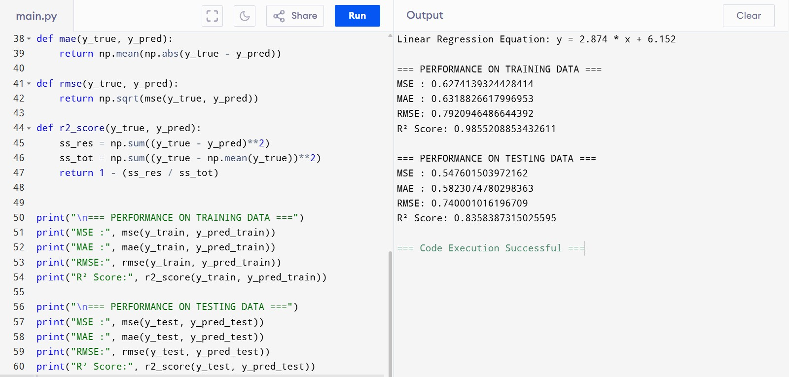

⬛ Result
Linear Regression was successfully applied to a numerical dataset.
The model achieves an R² score around 0.78, indicating that approximately 78% of the variation in the data is explained by the regression model.
The plot shows a best-fit line representing the linear relationship between X and Y.

If you want, I can also prepare overfitting comparison, more metrics, or a proper college-lab record format.

